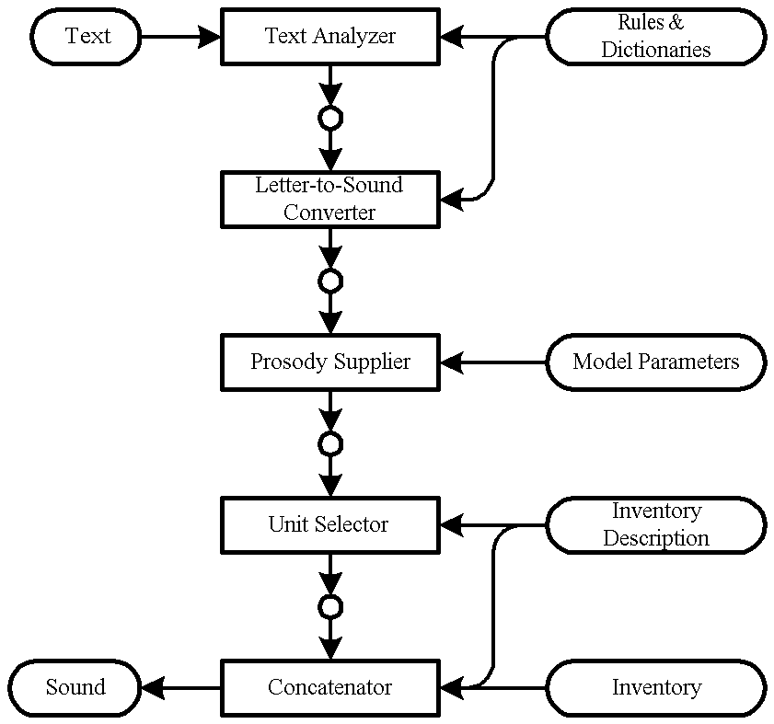

Problem Statement

Speech to text transcription for Indian languages. The problem entails transcription in the native script and then translation to English. The languages of interest are Hindi, Indian English, Urdu, Bengali, Punjabi.

Our Approach: Our project focuses on building a user-friendly platform that accommodates the various languages spoken across India, such as Hindi, Urdu, Bengali, Punjabi, and Indian English. Users can input audio content in their chosen language, and our platform will provide an audio output with an English translation. This initiative aims to facilitate communication across language differences within India.

Required Tech Stack:

HTML

CSS

JAVASCRIPT

Basic Flow

The flow of the execution of program includes following steps:

Input of Native Language Audio

Pre-processing of the data - Noise reduction and voice enhancement

Language Recognition - outputs language code (hi, bn, pu,...)

Forwarding the audio to the model of the recognized language

Trancripting it to Native Language Text

Translating it to English Language Text

Transcripting it to English Language Audio